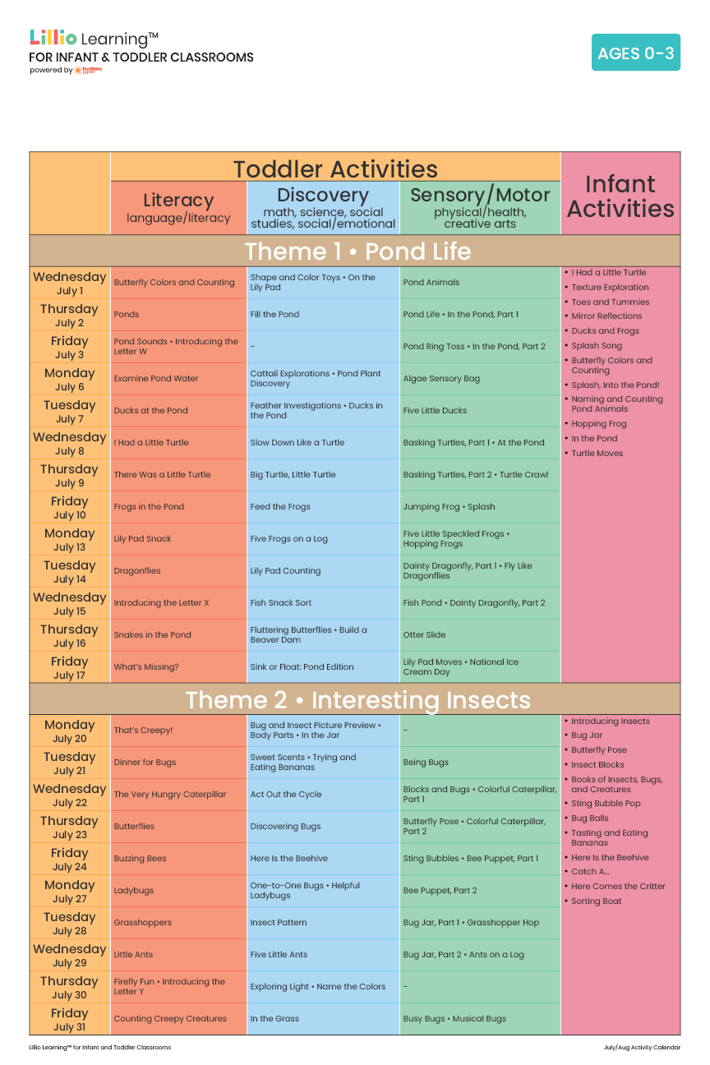
Add Your Name/Logo Here
July 2026
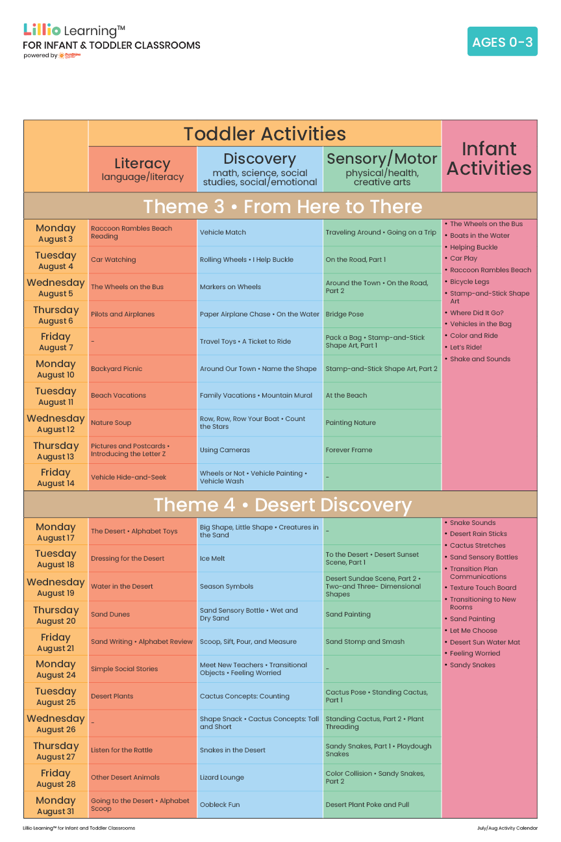
August 2026
Add Your Name/Logo Here

